
JADE News Beverage 2-2026
Dear Beverage Professional
Now is the right time to plan upgrades and capacity expansions for the upcoming production season. JADE offers a strong selection of high-quality beverage processing and packaging equipment, including complete brewery installations and modern packaging machinery.
Explore the listed selection and find equipment for your next investment or production project. For technical specifications, additional photos and further information, visit the JADE website to view our featured equipment and complete inventory.
Give us a call or send us a mail and we will respond, my WhatsApp +358-50-3746777 and email jari.kartano@jade.fi

You can download this JADE News in pdf-format via this link: JADE Beverage News 2 -2026

Cheers / Jari

____________________________________________________________________
PACKAGING AND PROCESSING EQUIPMENT

11062028 Tunnel Pasteurizer Single Deck EUROPOOL 24,000 bph - 2022
- Excellent condition, for beer and beverage in glass bottles and cans
- Made in 2022, very little used, operation stopped in Dec 2025
- Single deck, 7-Zones, Steam heated, PU control, Heat recovery system
- Capacity beer in 330ml glass bottles 24000 bph, beer in cans 30000 cph
- Siemens S-7 series PLC with a Siemens KTP700 operator panel
PRICE: By request for serious customers

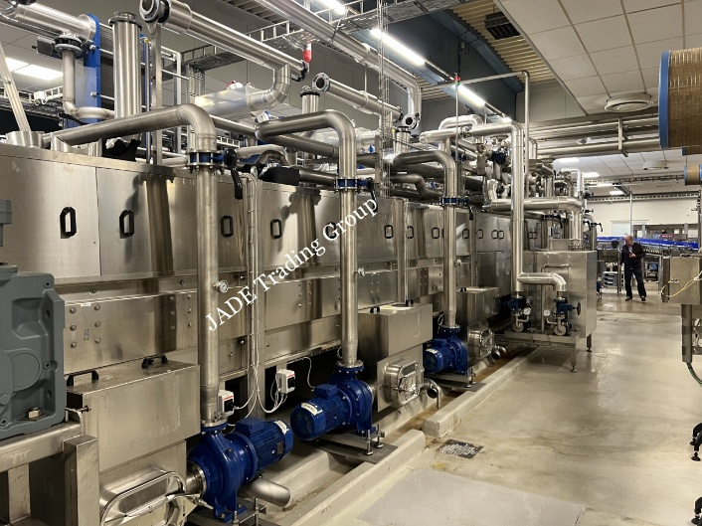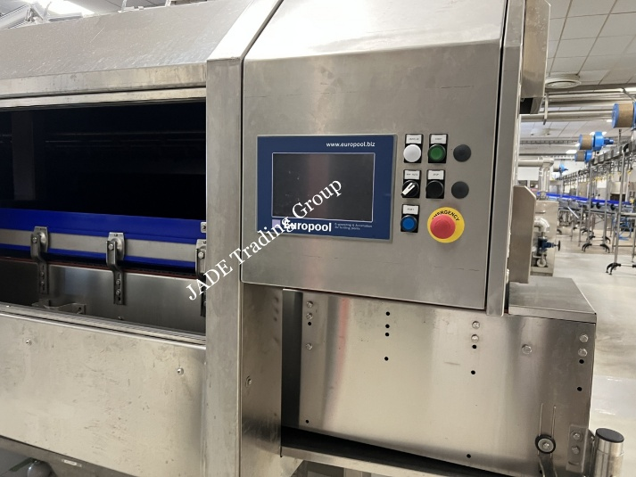
11082026 KHS Innopack Kisters SP High Speed Shrink Packer - 2017
- Complete shrink packing system with indeed and outfeed lines for cans and bottles
- Made in 2017, operated less than 10000 hours, top condition shrink packer
- High capacity up to 80 tacts/min, 42000 container/h
- Two-roll shrink film feeding, capable to process pre-printed shrink film with accurate print registration, allowing branded film graphics to be correctly positioned on each finished multipack.
- Current used pack formats 330ml 3x4 and 3x4, 500ml 2x3 branded film graphics
- Operation controls Siemens Simatic S7-400 PLC with KHS HMI
PRICE: By request for serious customers
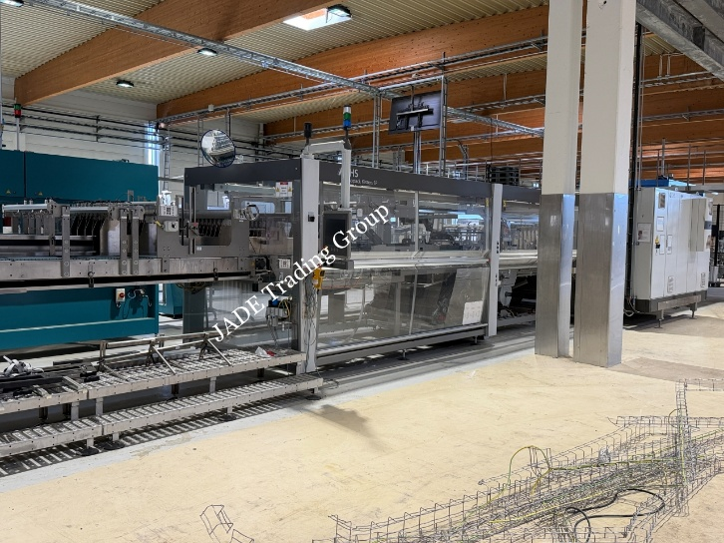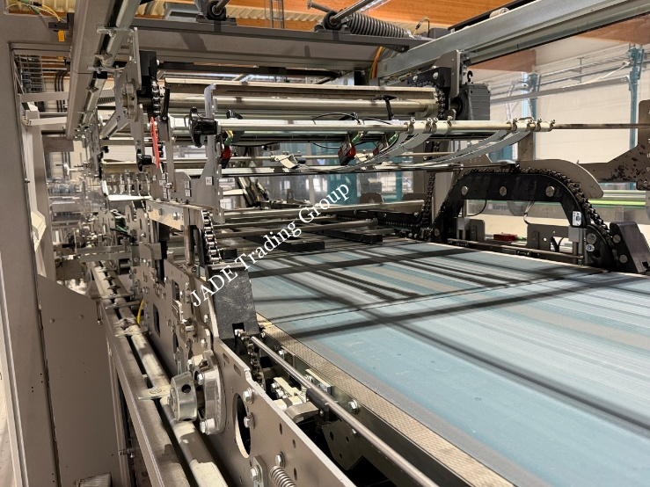

1111206 Carton Wrap Multipacker GPI Marksman 750HS with Turner/Divider - 2017
- Made by Graphic Packaging International in 2017, having approx 9000 operating hours
- Type Marksman 750HS continuous-motion multipacker, designed for secondary packaging of beverage cans into mechanically locked paperboard multipacks (without adhesive)
- Capacity up to 250 packs/h, current formats 2x2 and 3x3 (330 and 500ml)
- The Turner/Divider receives finished multipacks from the Marksman 750HS and arranges them according to the required downstream conveyor configuration
- Operation controls Siemens Simatic S7-300 with colour touch screen HMI
PRICE: By request for serious customers
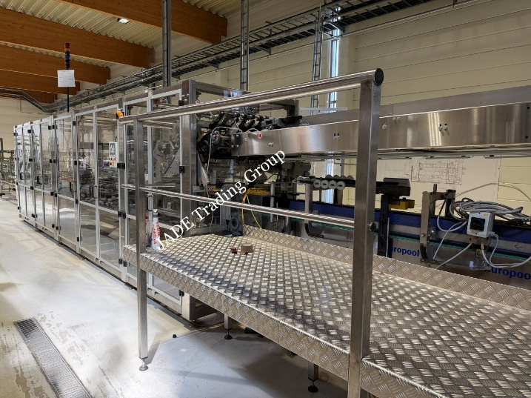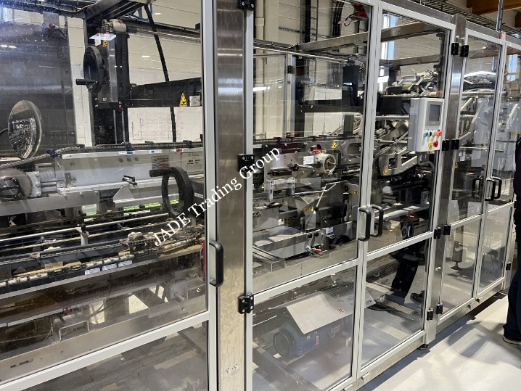

11042026 Rotary Labelling Machine P.E. Labellers MASTER 1120-20T - 2012
- Fully automatic 4-Station Self-Adhesive Rotary Labeller for Glass and PET Bottles
- Made in 2012 by P.E. Labellers, model machine Master 1120-20T-4S-2E
- Carousel has 20 pcs of servo rotated bottle plates, capacity up to 27000 bph
- Suitable for the application of front, back, neck and additional decorative or promotional labels in a single pass, depending on bottle format and tooling
- The machine is especially suitable for bottling lines requiring flexible multi-label application, accurate label placement and fast changeovers between bottle formats or SKUs
PRICE: By request for serious customers
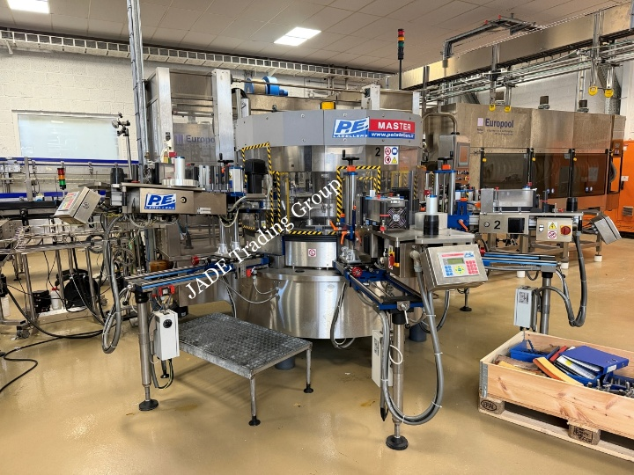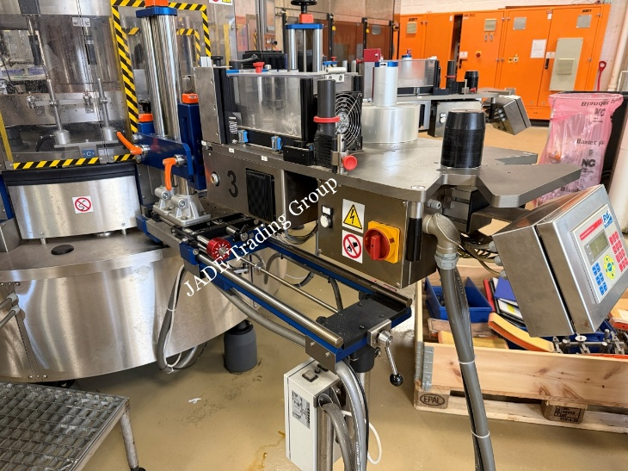

11132026 Krones Varioline 2M Glass Bottle Basket-Carrier Multipacker - 2019
- Krones Varioline 2M is a modular, fully automatic secondary packaging machine designed for grouping and packing glass bottles into printed paperboard multipacks
- Capacity upto 216 packs/h or approx. 28,000 bottles per hour for 330 ml bottles
- Top condition, total operating hours only approx 5000h
- Packing material Kraft board or Corrugated paperboard
- Operation controls Siemens Simatic S7-300 with Krones coulour touch screen HMI
PRICE: By request for serious customers
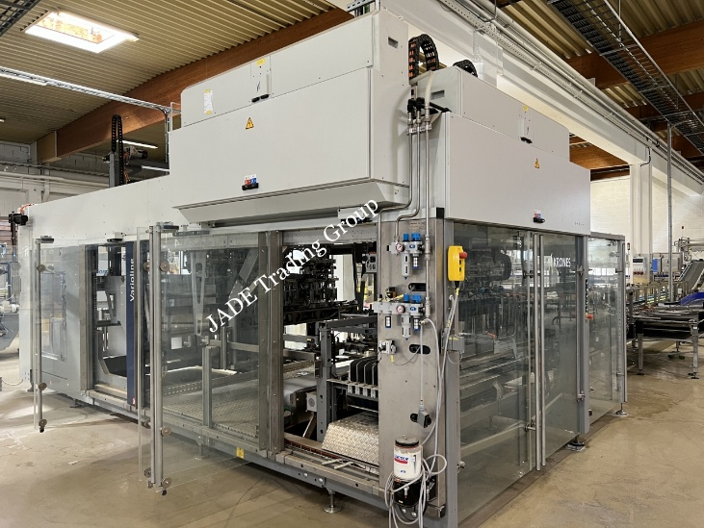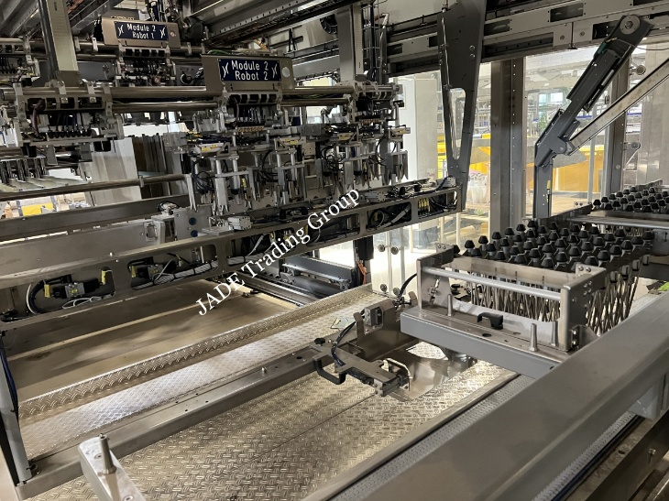

11022026 Glass Bottle Filling and Capping Monoblock KHS Innofill 32000 bph
- KHS Innofill ER-ZMS 80/7/15/15 is a 80 filling valve, counter pressure, fully automatic rotary glass and PET bottle filling and capping monoblock designed for the bottling of beer, carbonated soft drinks and other beverages in glass and PET bottles
- Originally made in 1994, completely serviced and refurbished in 2023
- Two separate 15-head cappers, one for Crown Cap, one for PET Screw Cap PCO 1810
- Change parts Glass 275ml, 330ml, 350ml, 350ml and 700ml PET 500ml and 1700ml
- Control PLC Siemens S7-1500 (new in 2023)
PRICE: By request for serious customers
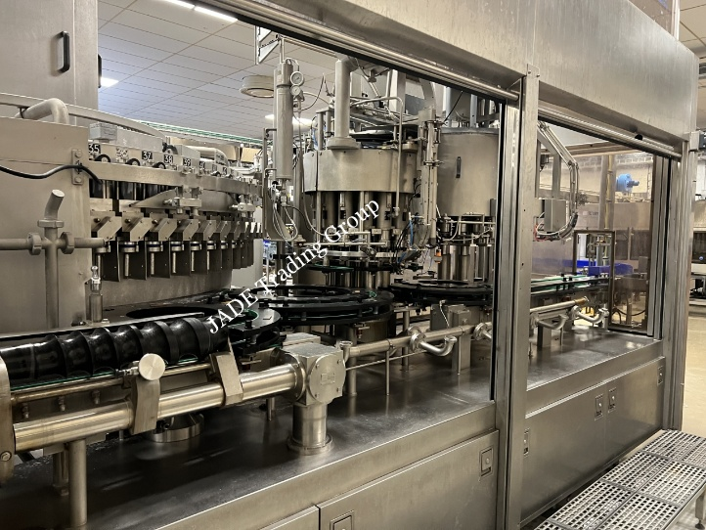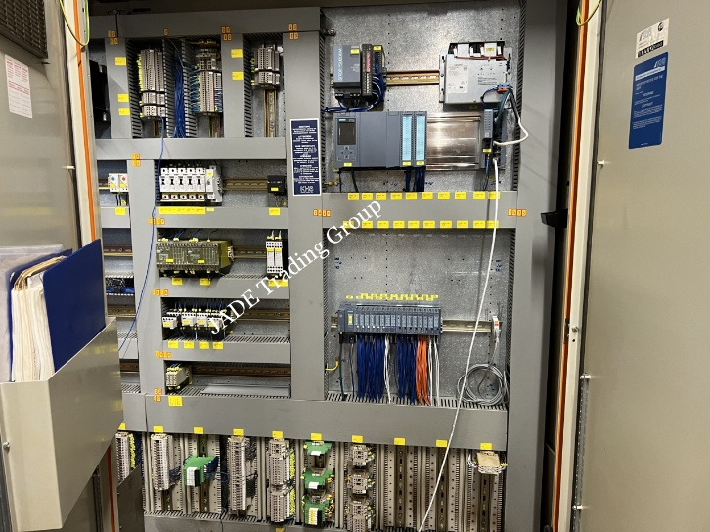

10822025 Labeller PE Rollmatic N 12T/540 Roll Fed Hot Melt OPP 16000 bph
- Manufacturer’s type Rollmatic N 12T/540/2 -3-375
- Manufacturing year 2006, operating hoursapprox. 32000
- Capacity min/max 4000 - 16000 bph
- Carousel diameter 540 mm, with 12 servo driven bottle plates
- Labelling stations, one with double reels
- Label type Hot Melt OPP Film
PRICE: Reduced for quick sale
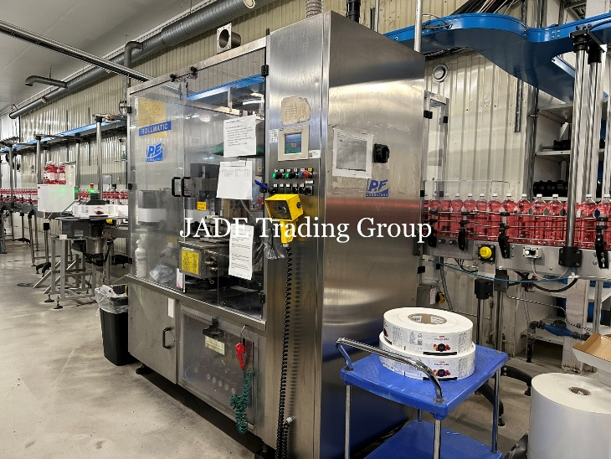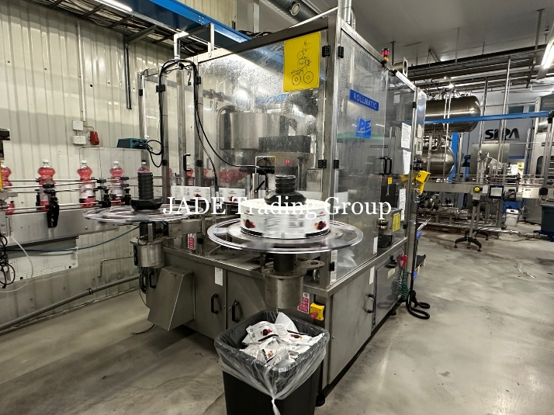
BREWERY DEPARTMENT

11052026 Modernized 200 hl Brewery with 6 × 540 hl CCTs and Siemens S7 Automation
- Complete, multi-vessel brewery from malt receiving to tank farm made by Ziemann, Huppmann and Seeger. Originally made in 1994 to 2008
- Completely rebuild and upgraded before re-installation in 2018, including new controls
- Brew volume 200 hl per brew / upto 8 brews per day, beer gravity up to 16 Plato
- Annual capacity brewing appox. 400,000 hl, fermentation capacity 6 x 540 hl CCT
- Brew Control system Siemens S7-1500 PLC automation
PRICE: By request for serious customers
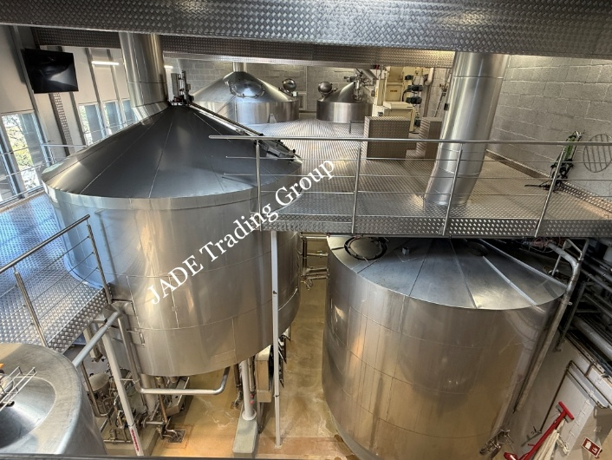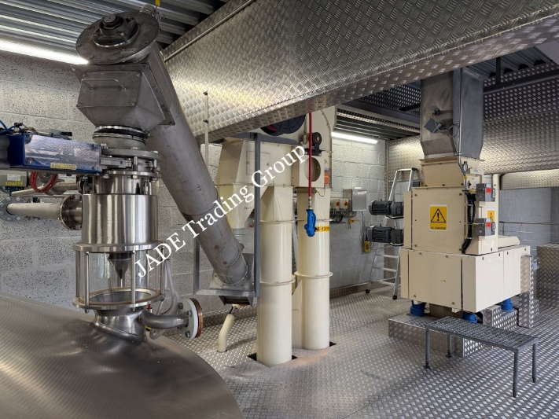

10962026 Micro Brewery Semiautomatic 2-Vessel 5hl Braukon 750hl/ annum - 2017
- Complete working brewery 5hl / Brew, 3-4 Brews/24 hours
- Brewline Braukon 2-vessel system with separate Whirlpool
- Cold block pressurized Mueller CCT 10x10hl, BBT 2x10hl
- Grist load 24.1 kg/hl for beer with 18°Plato, annual capacity upto 750hl
- Includes malt mill, Kieselguhr filtration and HopGun
- Top condition, still installed and can be tested
PRICE: By request for serious customers
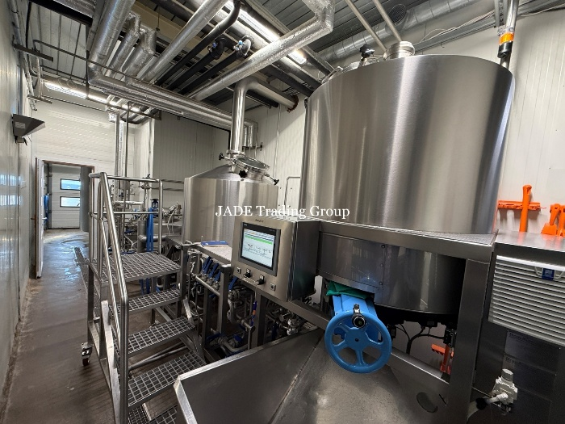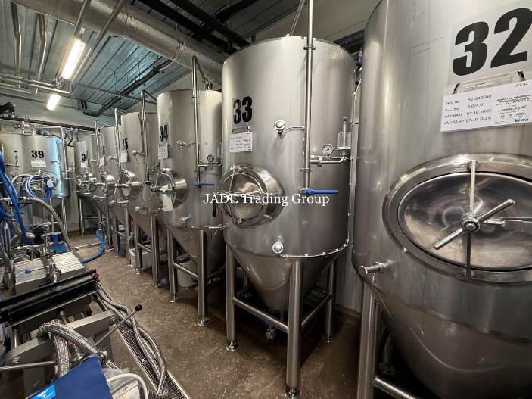

10982026 Fully Automated Brewery 30hl/brew with Meura Mash Filter - 2016
- Complete working brewery 30hl / Brew, 6-8 Brews/24 hours
- Three vessel configuration with Meura mash filter
- Cold block pressurized CCT 3x75hl, BBT 2x10hl
- This equipment presents the high-end European brewing technology
- All operations are controlled via Siemens S7-1500 (TIA Portable) series PLC systems with 2x Siemens Visualisation WinCC
- Includes malt mill, GEA centrifuge, KG and PVPP filtration
- Top condition, still installed and can be tested
PRICE: By request for serious customers
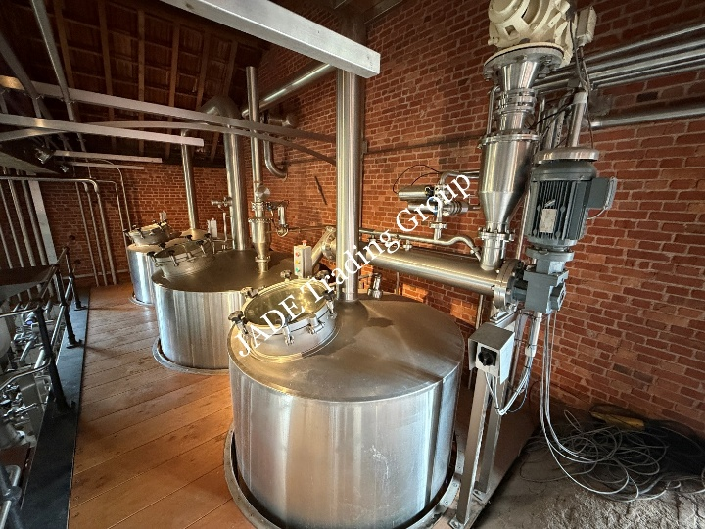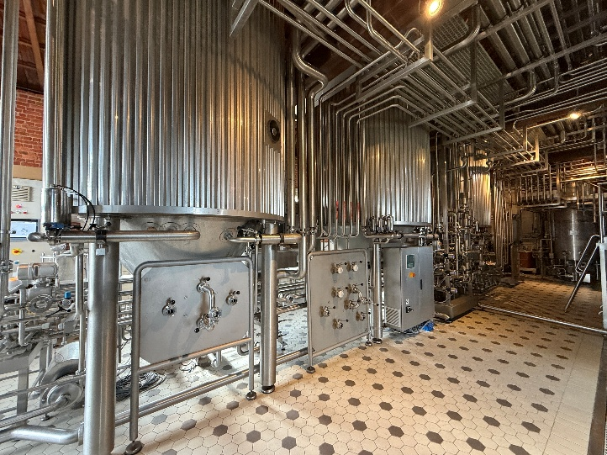

In Addition we have some other interesting equipment for sale – it is worth checking these!
11122026 PROGRIP TX 240 Carry Handle Applicator For Wrapped Multipacks -2017
11142026 Robopac Helix 1 Automatic Pallet Wrapping and Pallet Handling System-2017
11022026 Glass Bottle Filling and Capping Monoblock KHS Innofill 32000 bph
10462025 Complete Micro Brewery Brewiks 500L, 760 liters/brew – 2017
10882025 Semi-Automatic Shink Packer Smipack BP600
10892025 Semi-Automatic Bottle Washer AKOMAG Combi 150-500 bph

JADE Trading Group – your global partner

Helsinki, Finland
Jari Kartano, CEO & President
+358-50-3746777 mob + WhatsApp
jari.kartano@jade.fi

